Q1) As described in class load the 4 yearly files (1st tab only in a for each loop) into a staging    
     1) rename the files if you need to  
     2) edit the file to remove the extra items at the top of the tab  
     3) leave the data formated as is  
     4) leave it as an xls file or you can modify so it is a tab delimited  
     5) you should have on emapping from source file to staging area

As per the question,

The files are renamed, files are edited to remove the extra items and data formatted.

2013

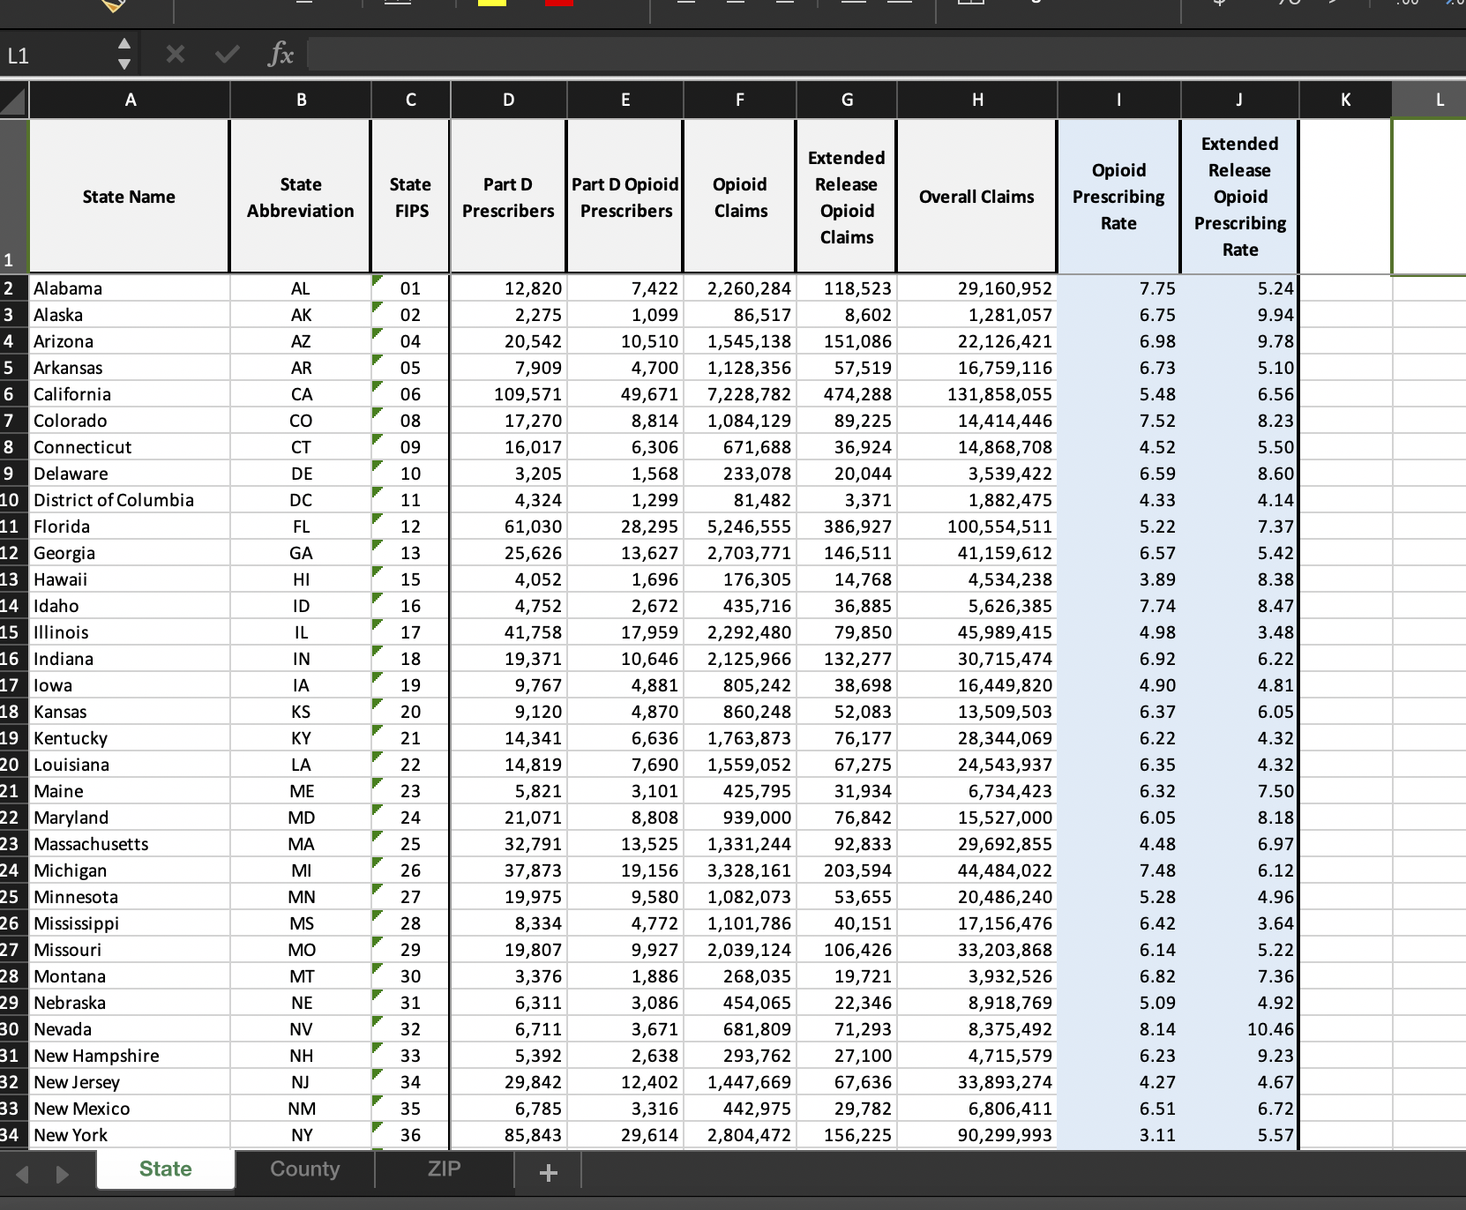

2014

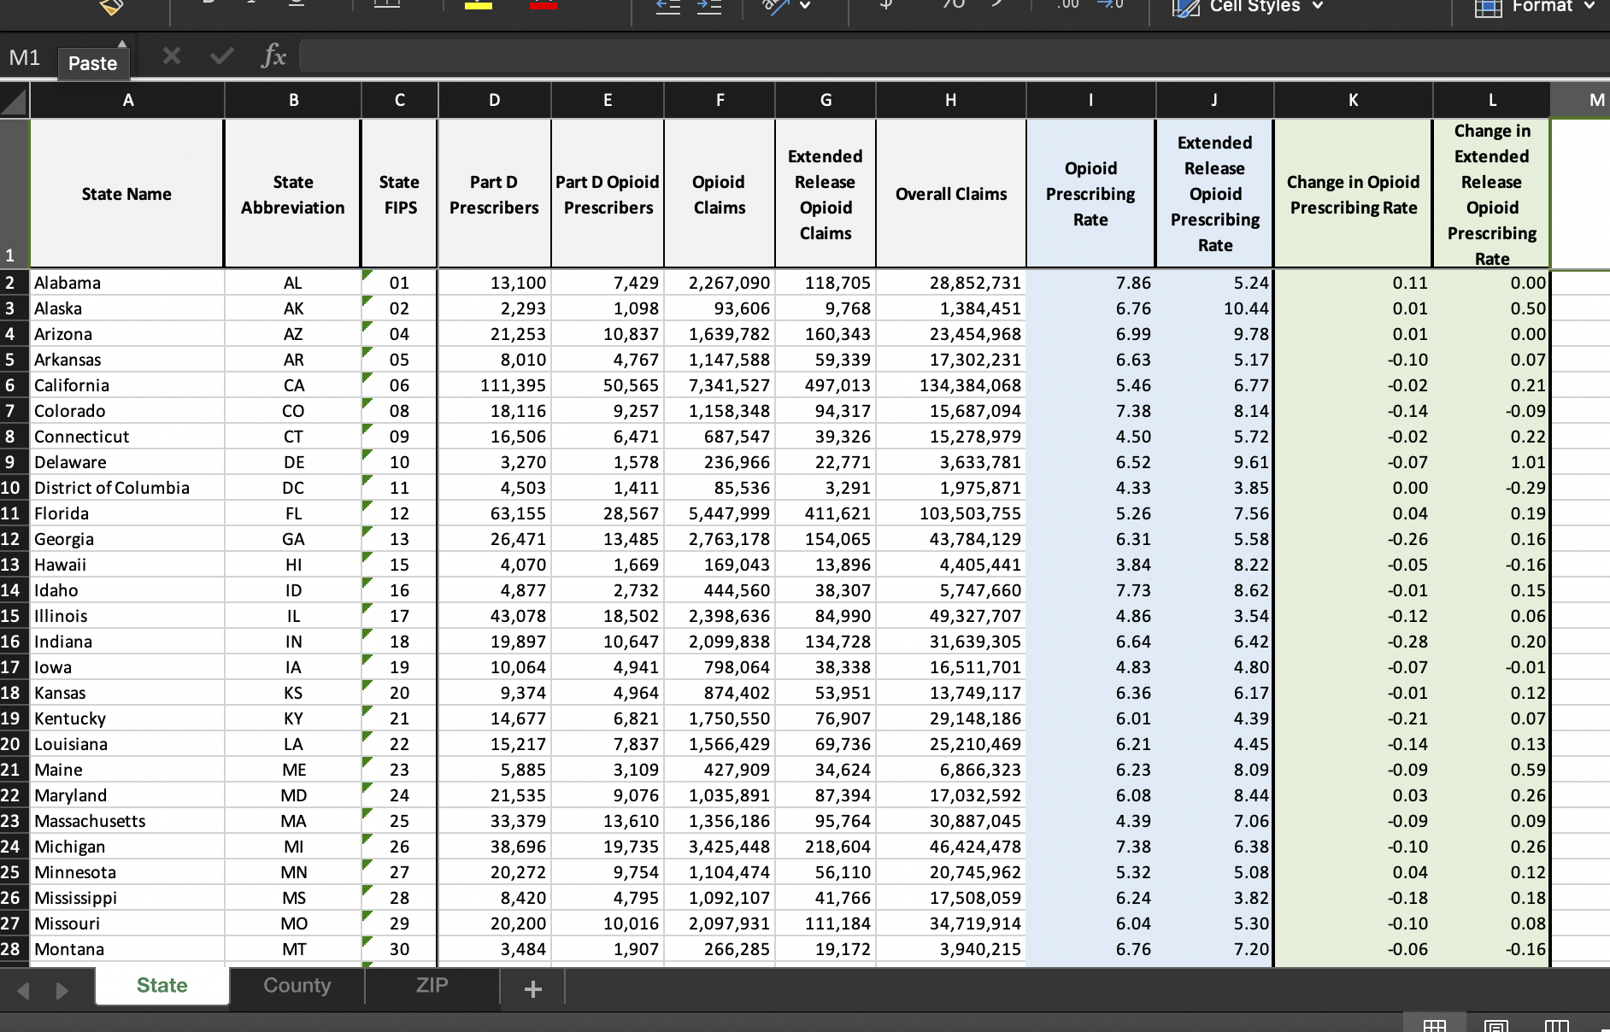

2015

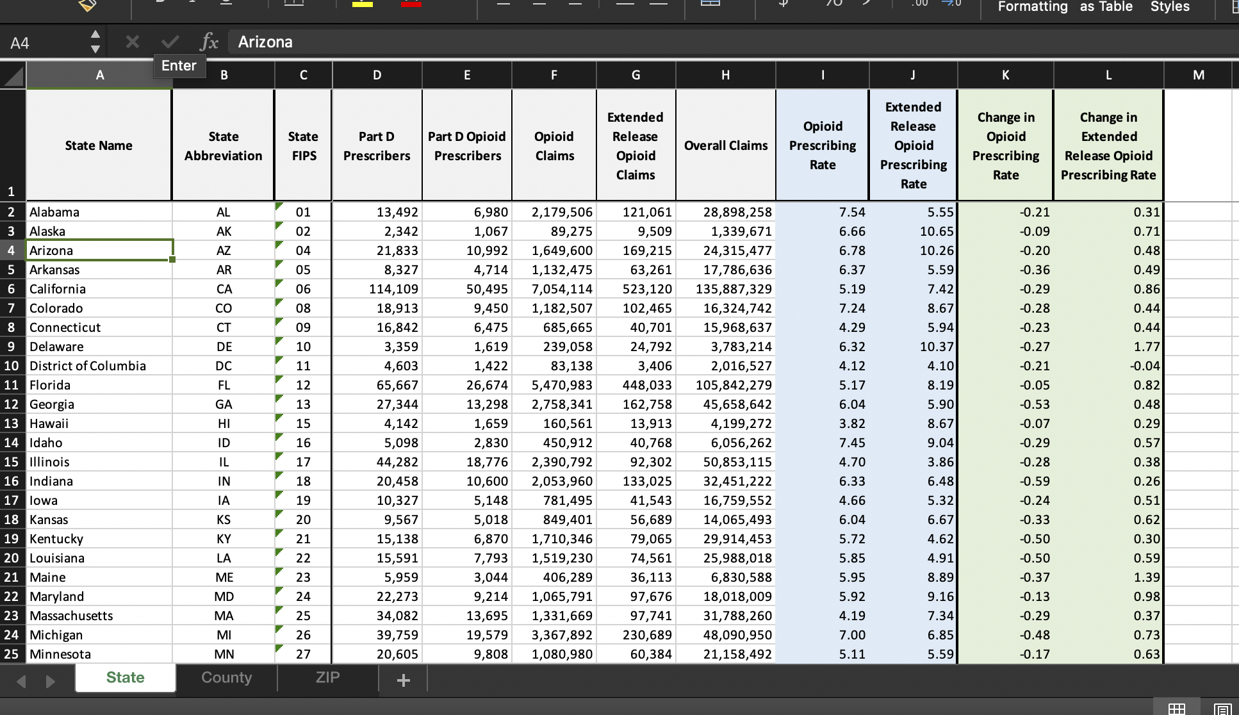

2016

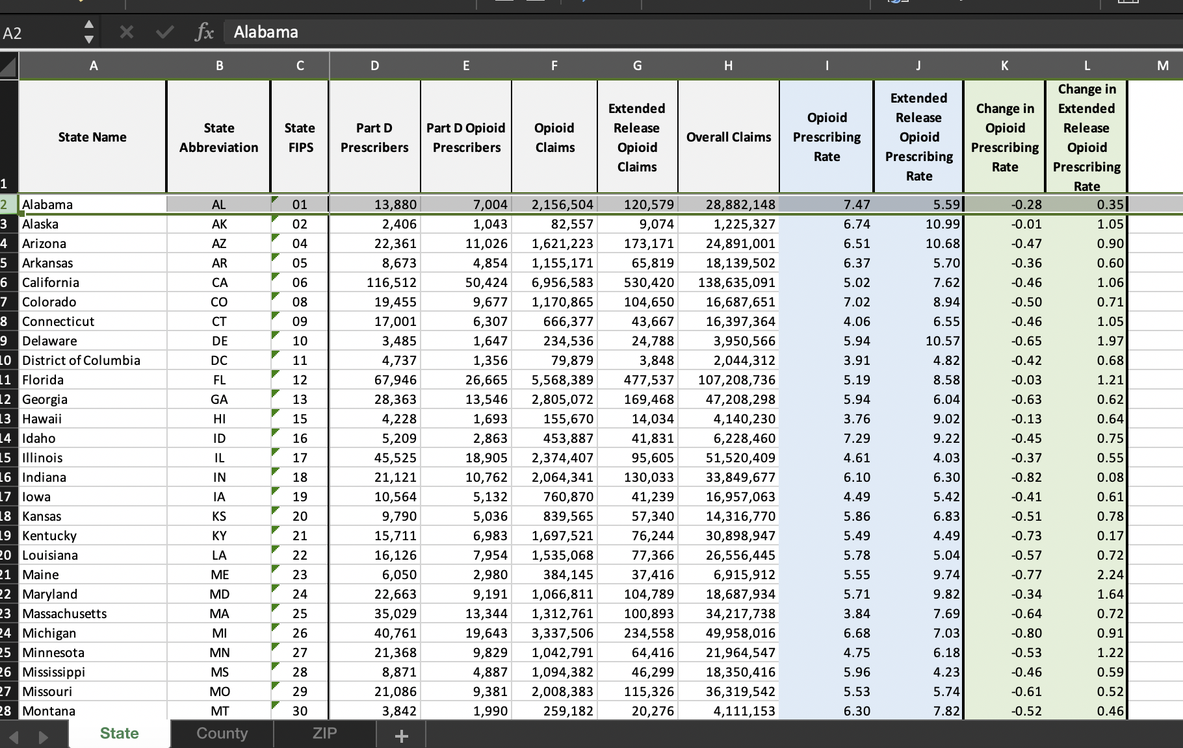

Excel file cleaned and converted to delimited tab file.

2013

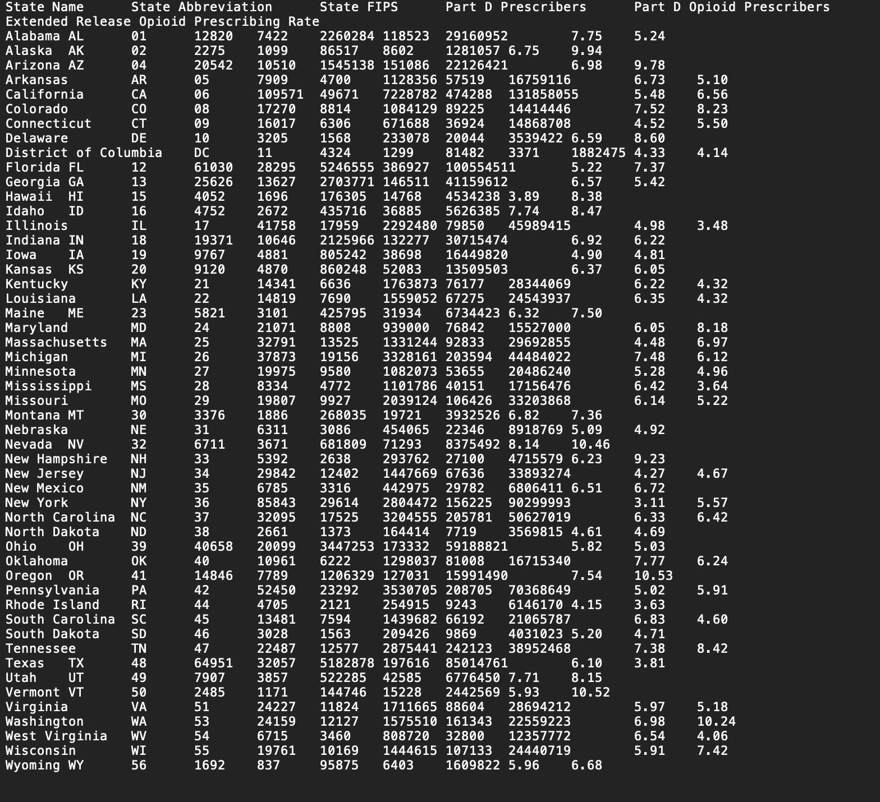

2014

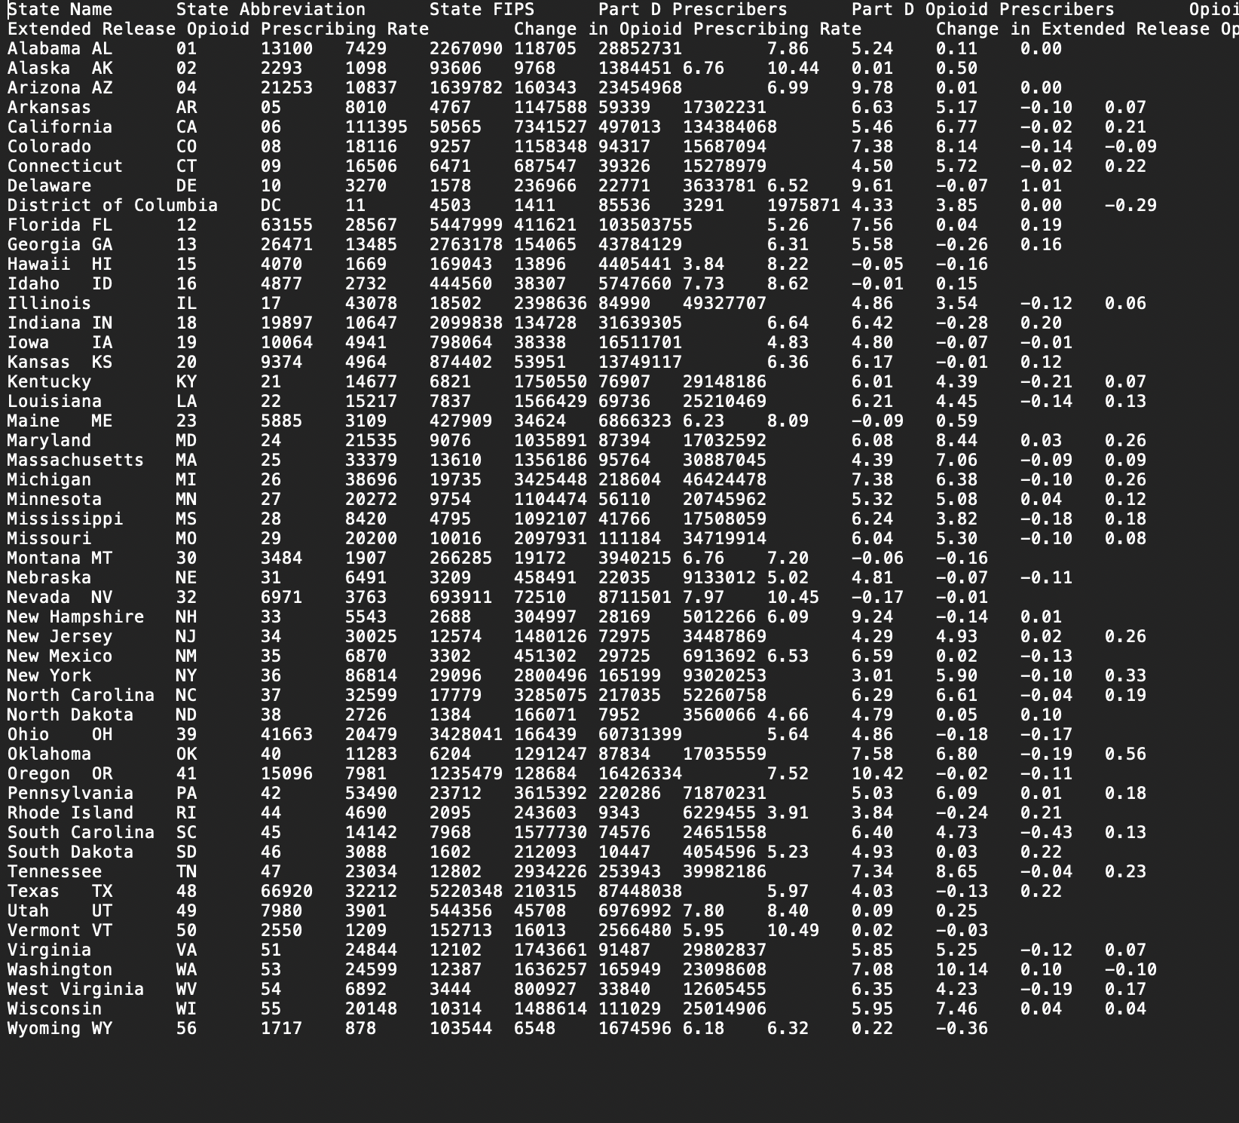

2015

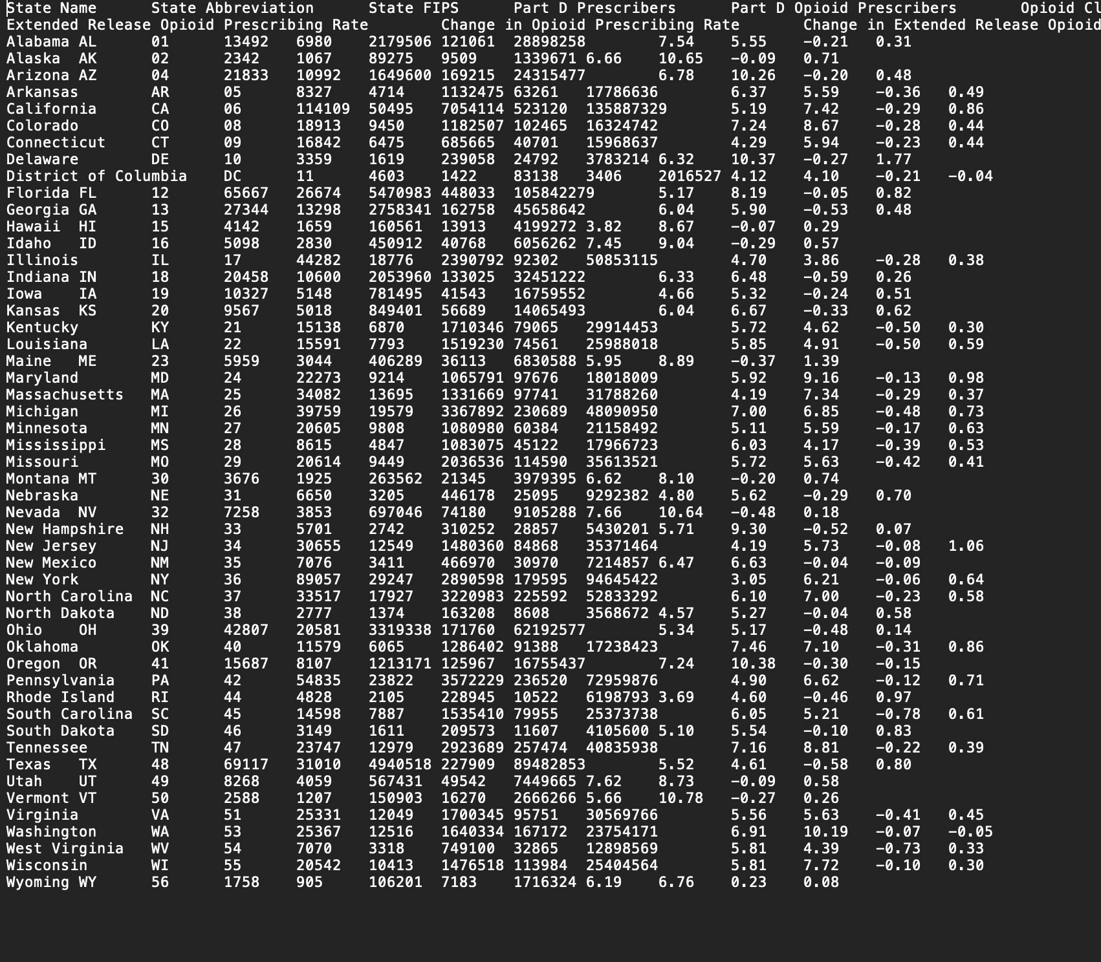

2016

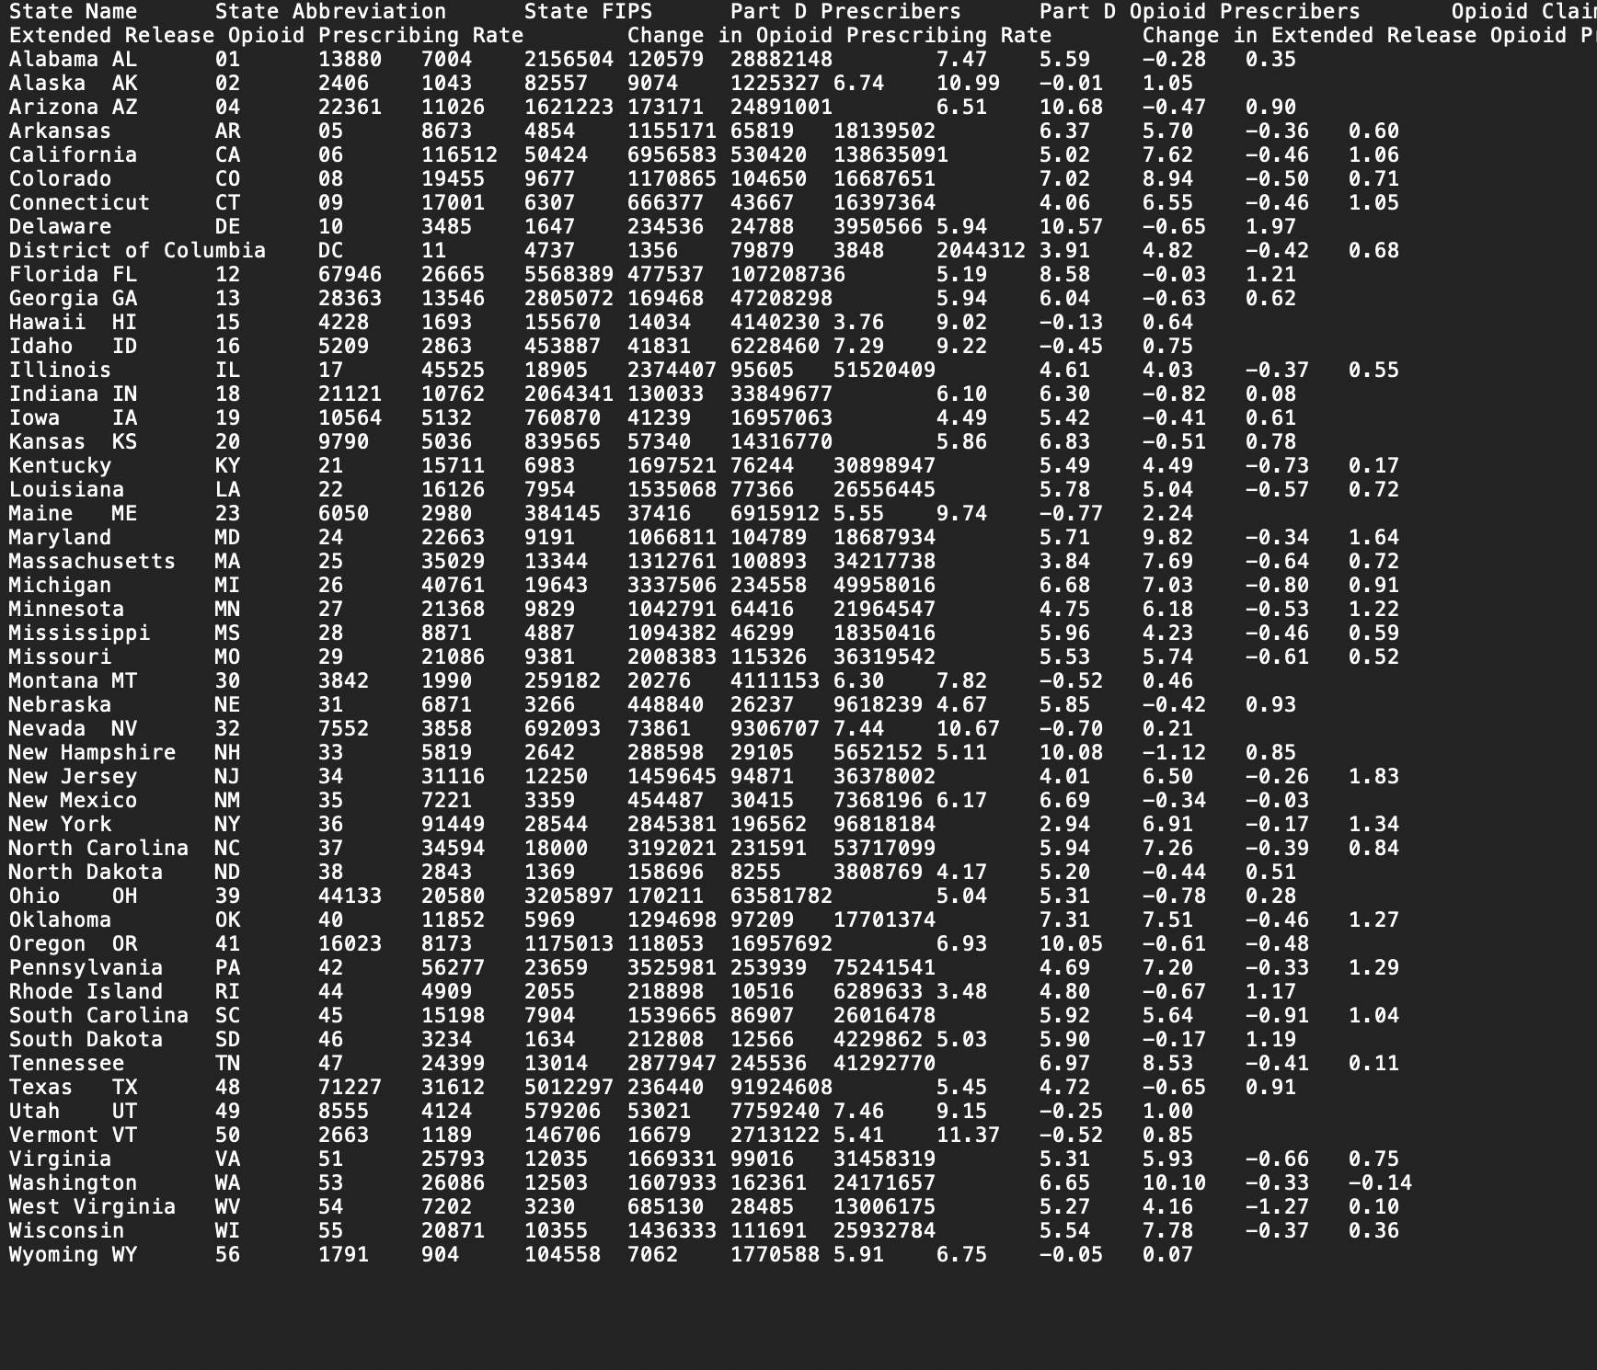

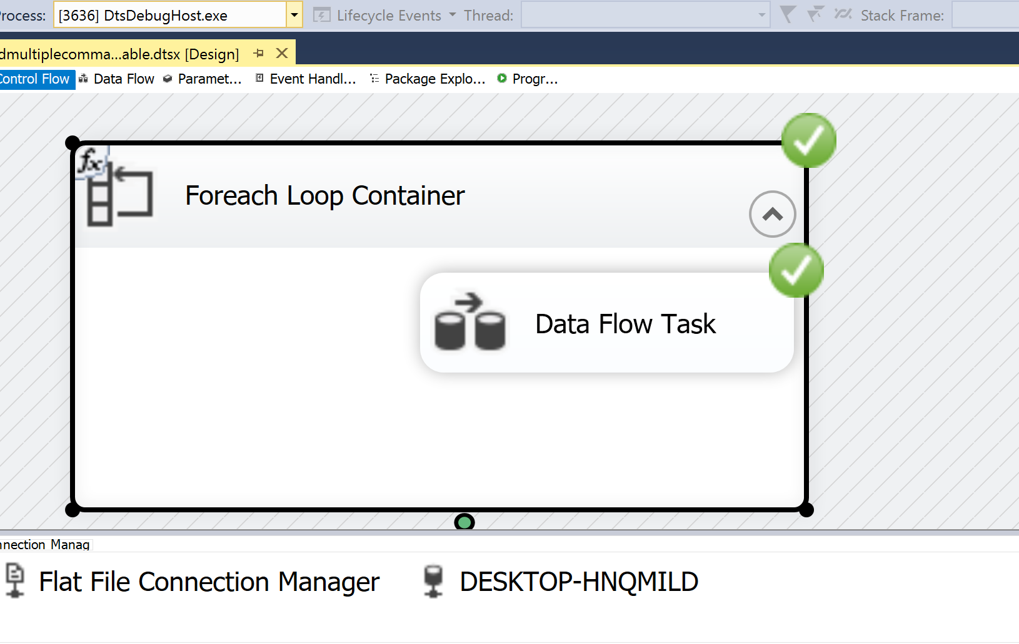

Inside the data flow task,

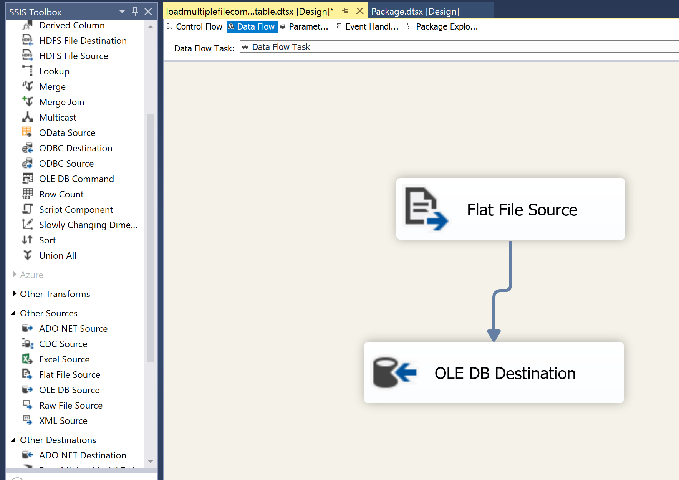

Q2) move the staging data into a destination table  
     1) add a column for the year   
     2) add another for the load date.  All rows for a file should have the same date and time for a load date.

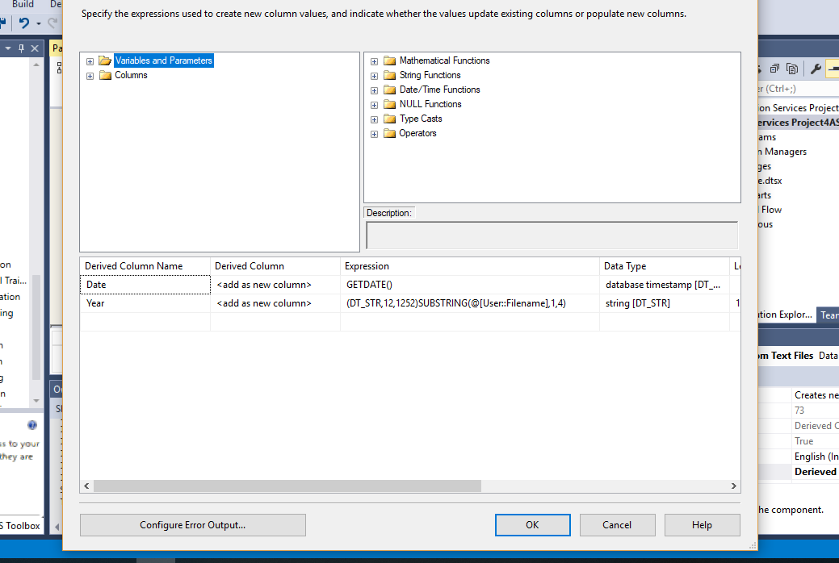

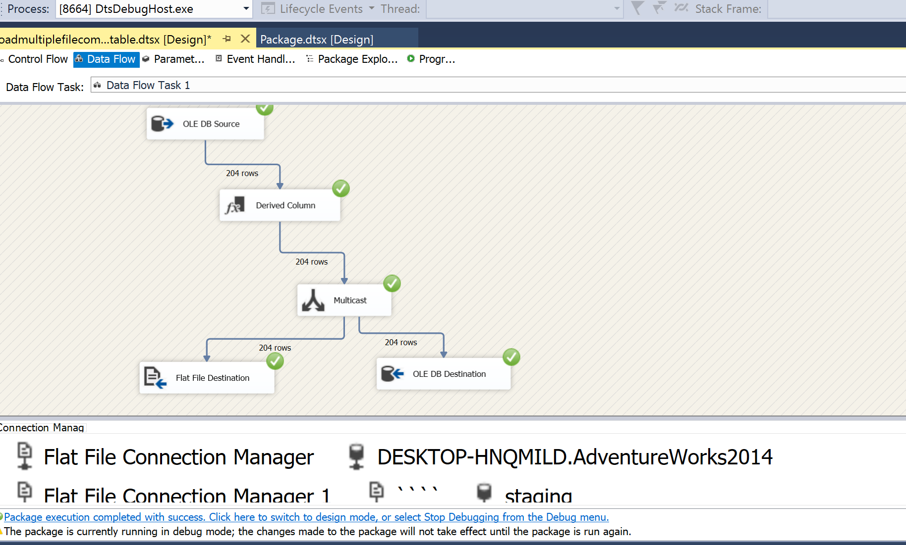

Q3) After completing the load you should move the data to an archive area with the additional columns?

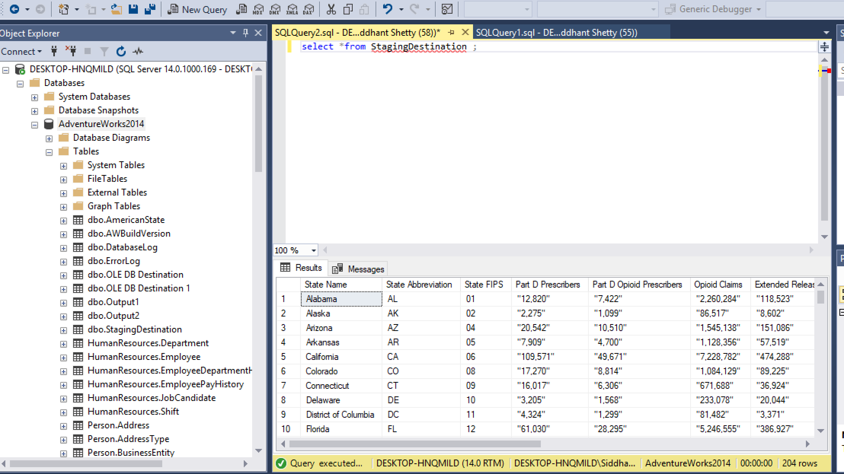

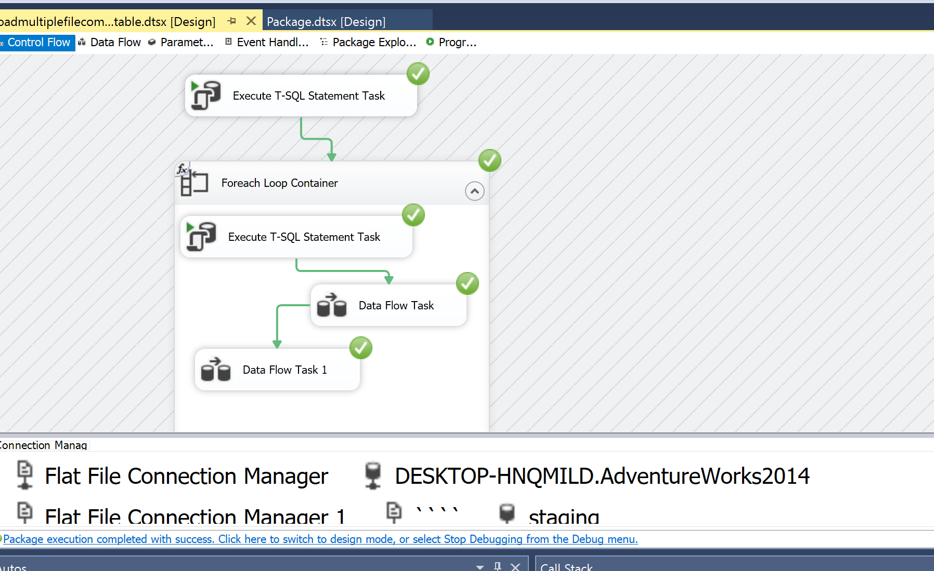

Q4) national totals row as a way to validate the load of each file   
     1) do not load the national total into the destination table

